Khao Pheng Ma, Wang Nam Khiao BH3 outstation 29 May 2021
10th anniversary of the original run in the Khao Pheng Ma National Park
Hares: Vichai ‘Cool’ and Lem ‘No good Boyo’
Run.
An open outstation for BH3 members and their wives/girlfriends. Ten years ago, we ran on virgin trail through the National Park along many Gaur tracks. Today, the Gaur population has increased so much in the area and the DNP does not encourage anyone trekking through the area. However, we are able to stay along the border of the National Park and we have a short ‘walkers’ green trail of 4.5km but a main trail of 6.5km and option for a further 2.0km for runners. A totally green trail including hills and bush.
Accommodation.
Suchada Garden
Wang Nam Khiao
https://goo.gl/maps/TK87BuT3Sd7HSKX38
Suchada Garden is approximately 4hrs drive from Bangkok. Khao Yai south side.
http://suansuchada.com/
Room booking to ‘May’ 082 862 9517
suansuchada@hotmail.com
Mention ‘BH3’ when booking for BH3 discount, make a full or 50% deposit and confirm to suansuchada@hotmail.com and copy to lemuelmorgan@gmail.com so that we can keep track of numbers.
Deposit: K Bank 445-2-02404-2. Suchada Losakunsin.
Rooms available to us. Lake Villas 15 mix twin and double beds. Pool Terrace 15 mix twin and double beds.
Lake Villa: B1,200 (B1,000 singles). Pool Terrace B1,300 (B1000 singles).
Vichai Cool: 081 443 9042; Lem Morgan: 089 888 4320
Lake Villas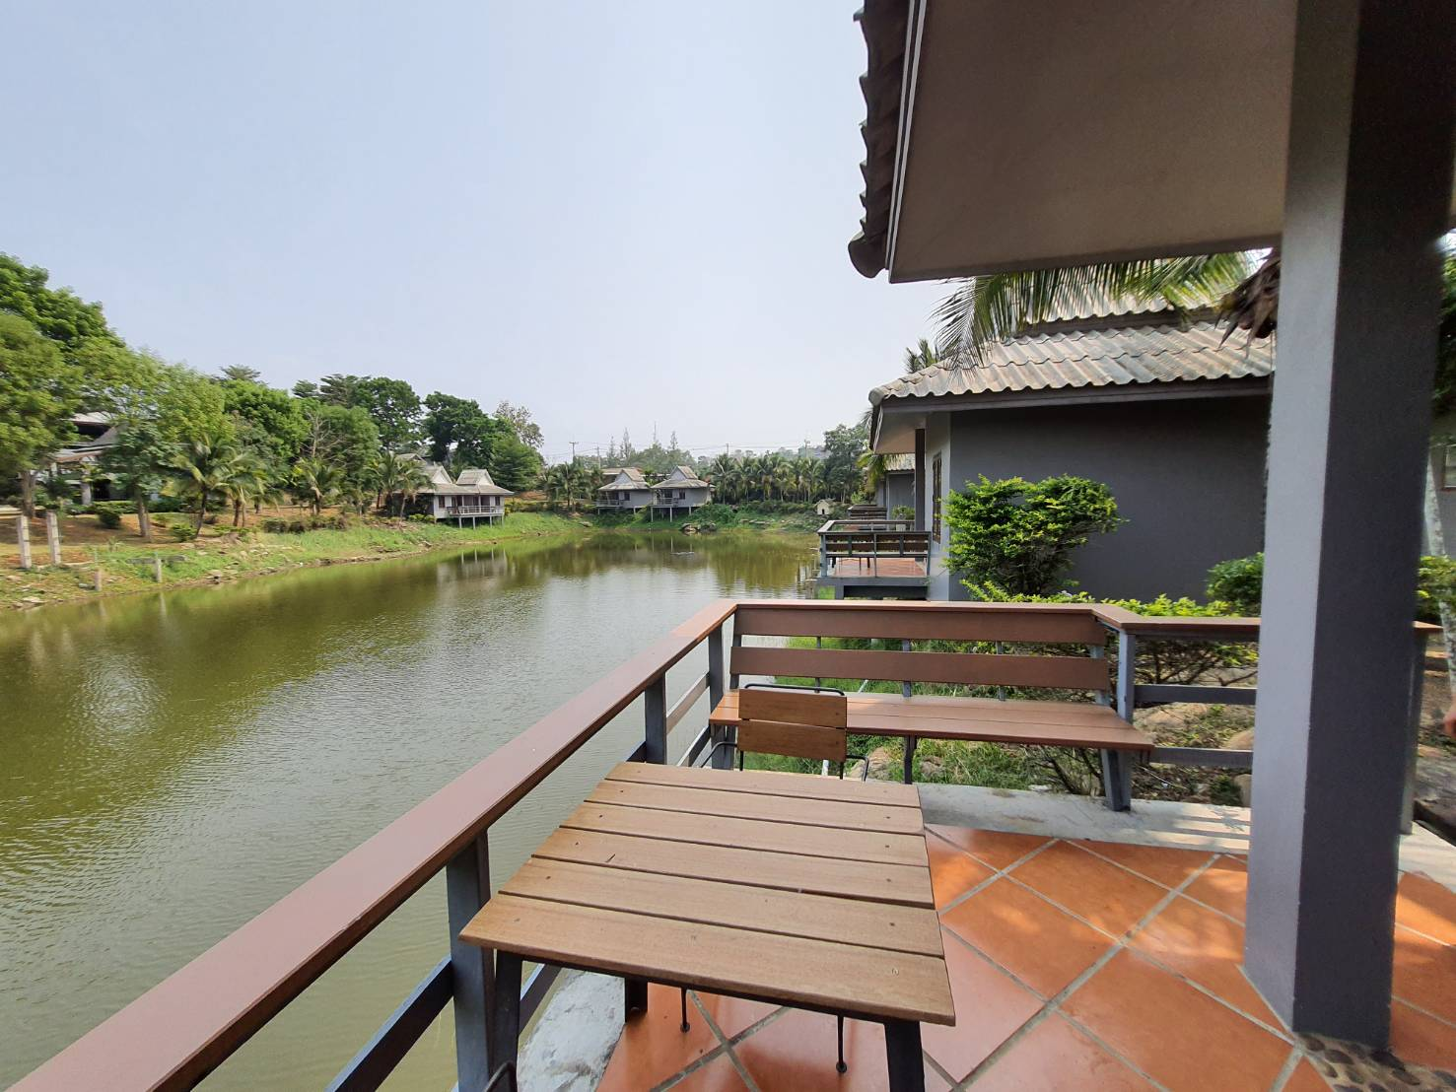 Pool Terrace 